**HOMEWORK-2**

**Twitter Service**

**Done and Submitted by**:Jayanth Vishal Reddy Godi **SJSU ID:**0167200800  
**Professor**:Andrew Bond  
**Date**:09-18-2022



**Logo reference:**

https://www.dreamstime.com/twitter-logo-bird-isolated-over-white-background-social-media-networking-communications-symbol-breaking- news-image130861855

**Setting up the environment**:

• login into the following link and signup with the twitter account for developer Portal.

**link:** https://developer.twitter.com/en/docs/ads/general/overview/ ads-api-sandbox.html

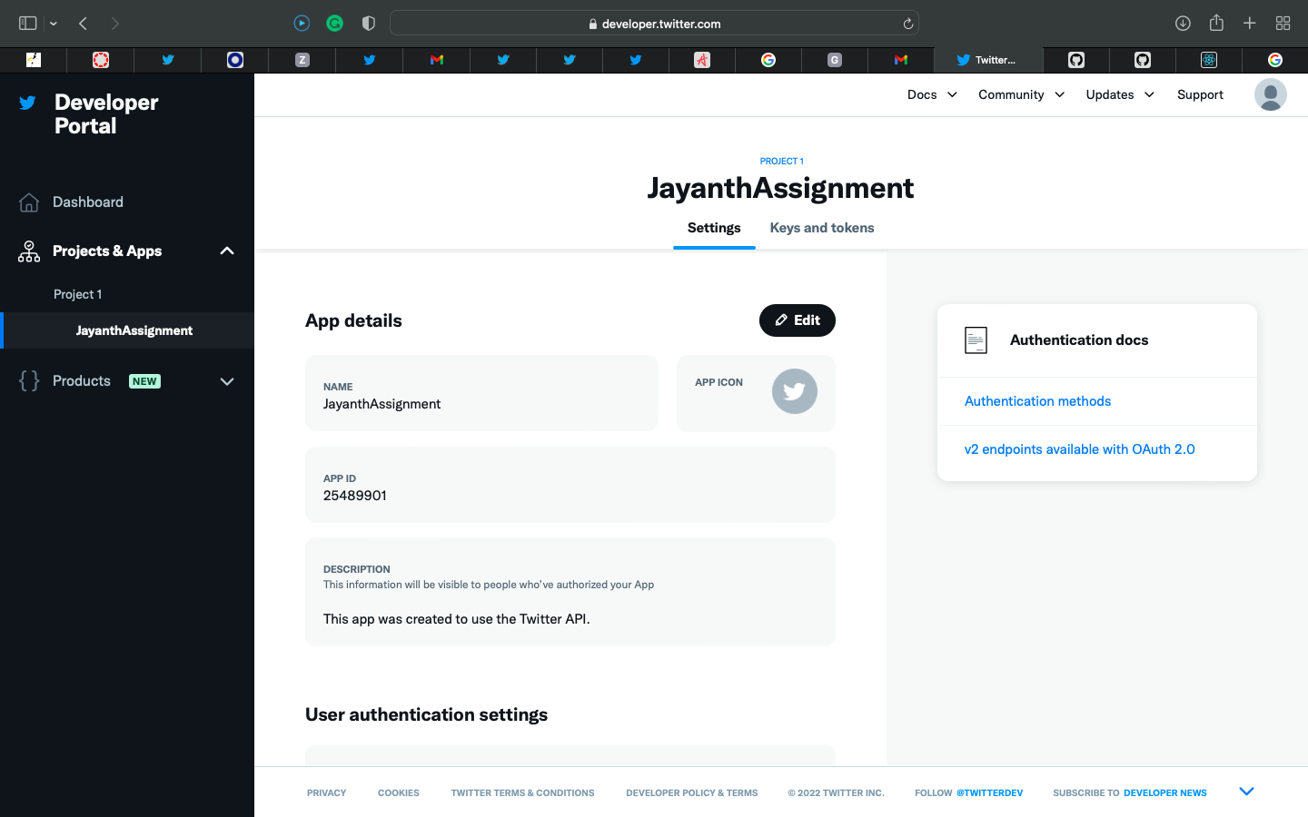

• Give the read and write permissions to make changes in the developer portal.

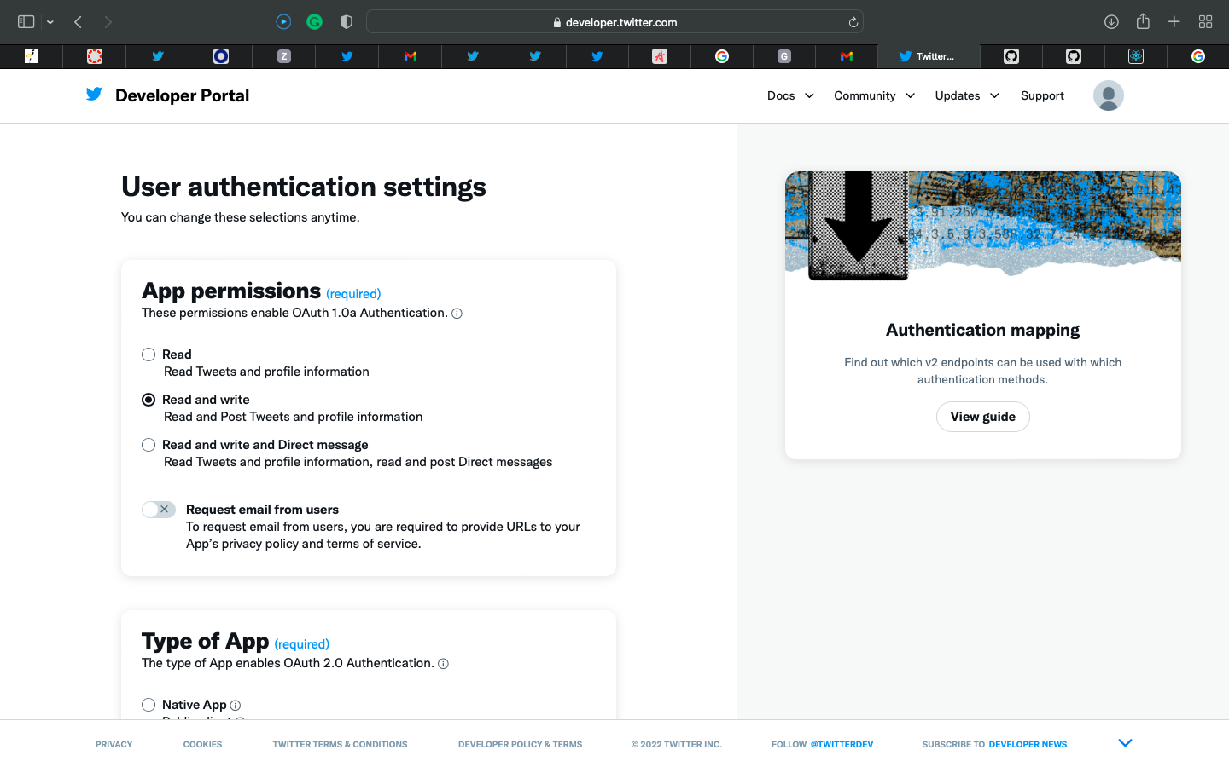

• Generate the required API keys and Tokens that are useful for the further process

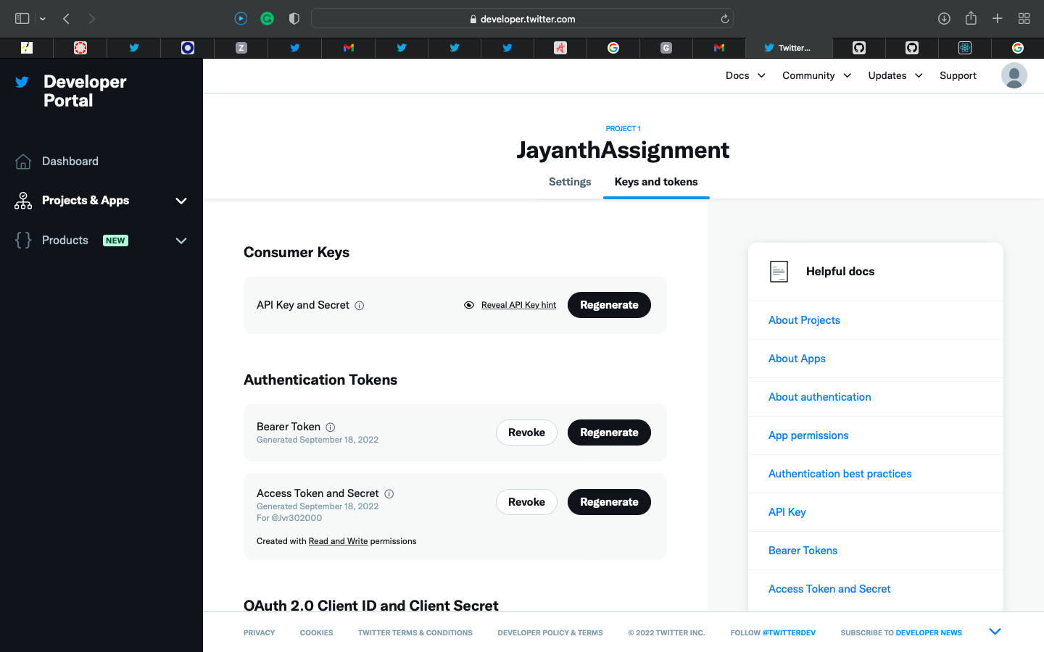

• OAuth 2.0 Client ID plays a keyhole in connecting with API

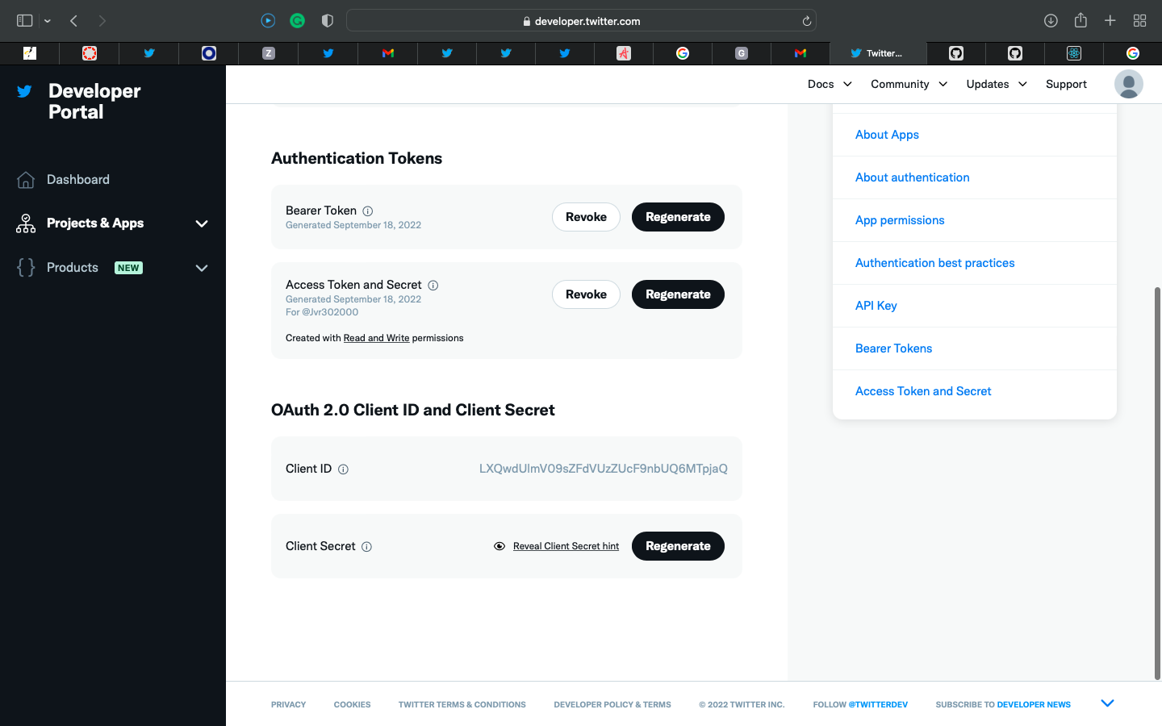

• Install POSTMAN app for API testing.

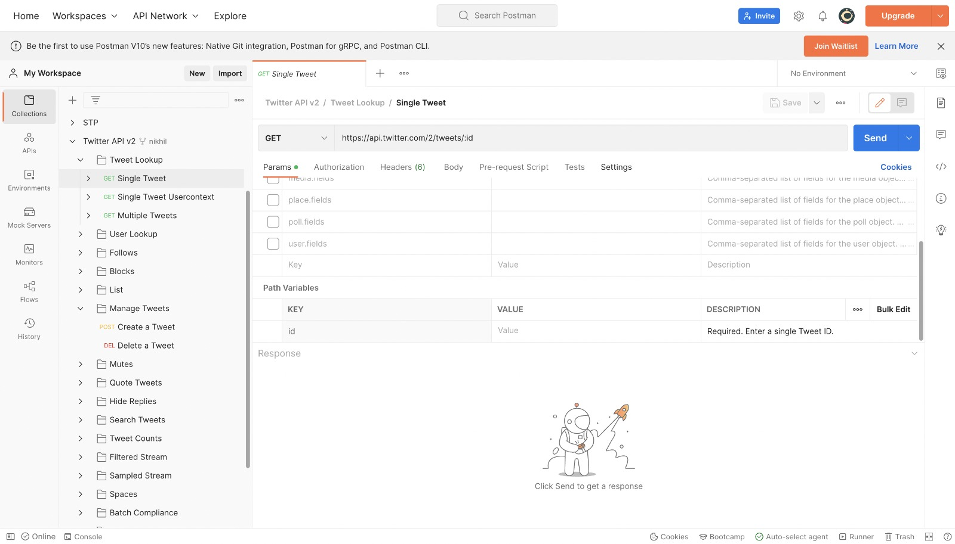

**Getting a TWEET Using Tweet ID:**

• Connect both front & backend to the Twitter API v2  
• I have designed my model so that it can display the tweet

using Tweet ID.

•

This is the example of a random tweet found in the twitter application

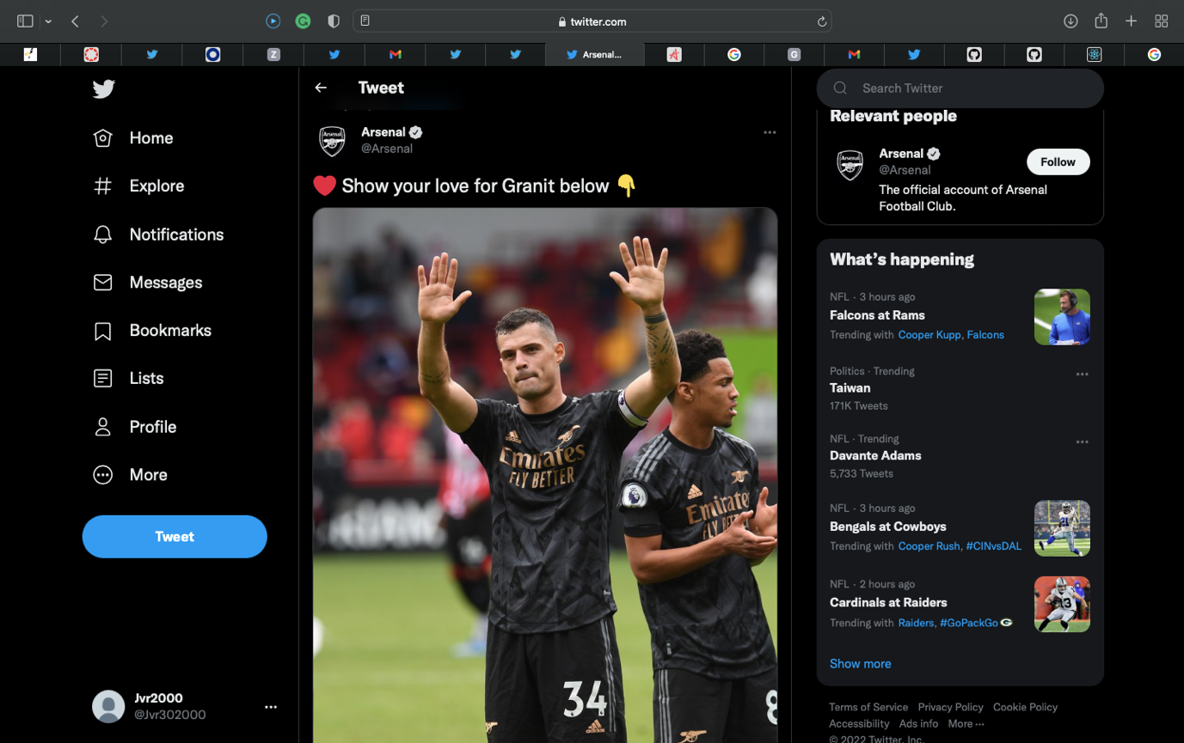

• I’ve taken the Tweet ID form the random tweet found in the twitter application.

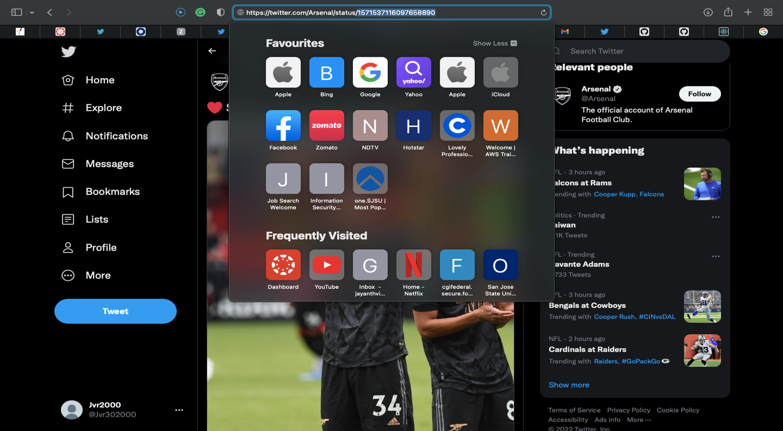

• Here’s the output of my model

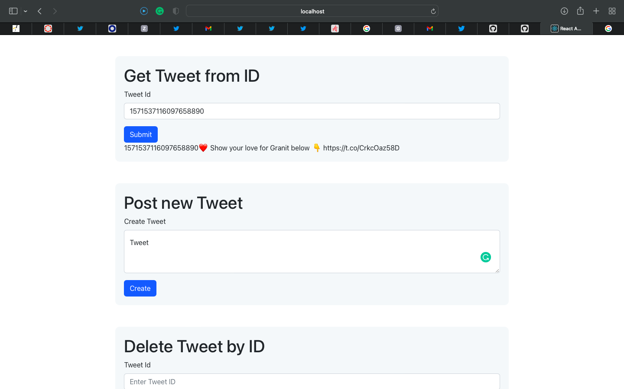

**Creating a TWEET :**

• I’ve designed my model so that if we tweet a random post it returns us the Tweet ID for deletion purpose too.

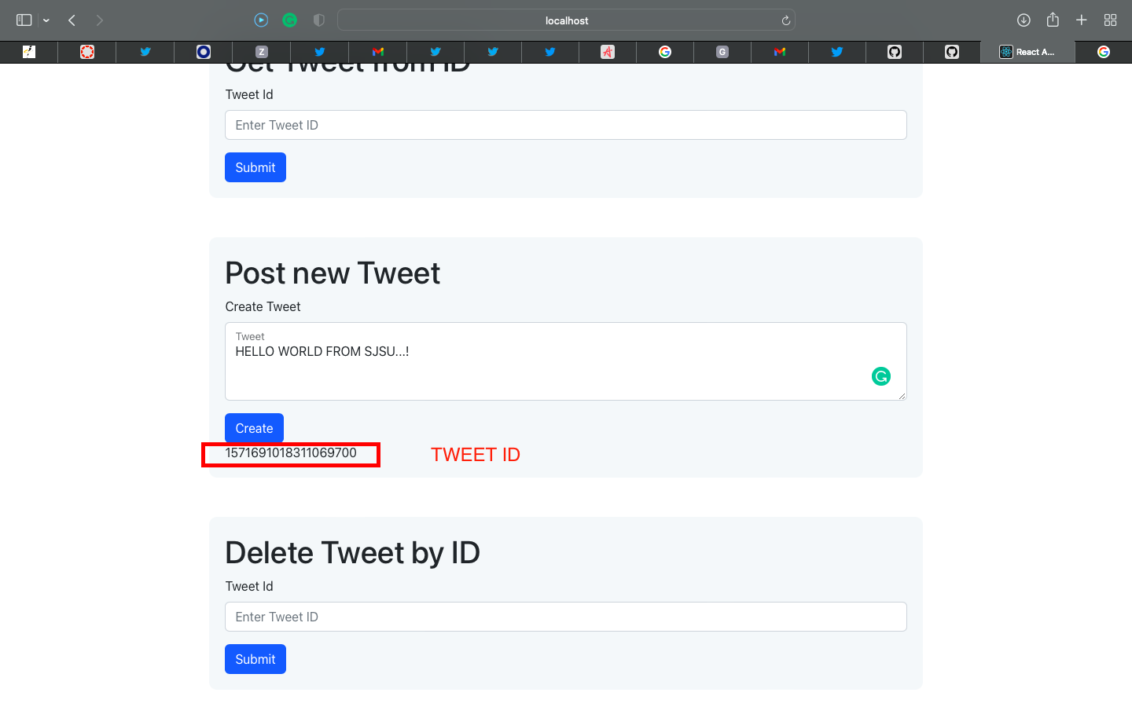

• Here’s the output of my model of creating the tweet.

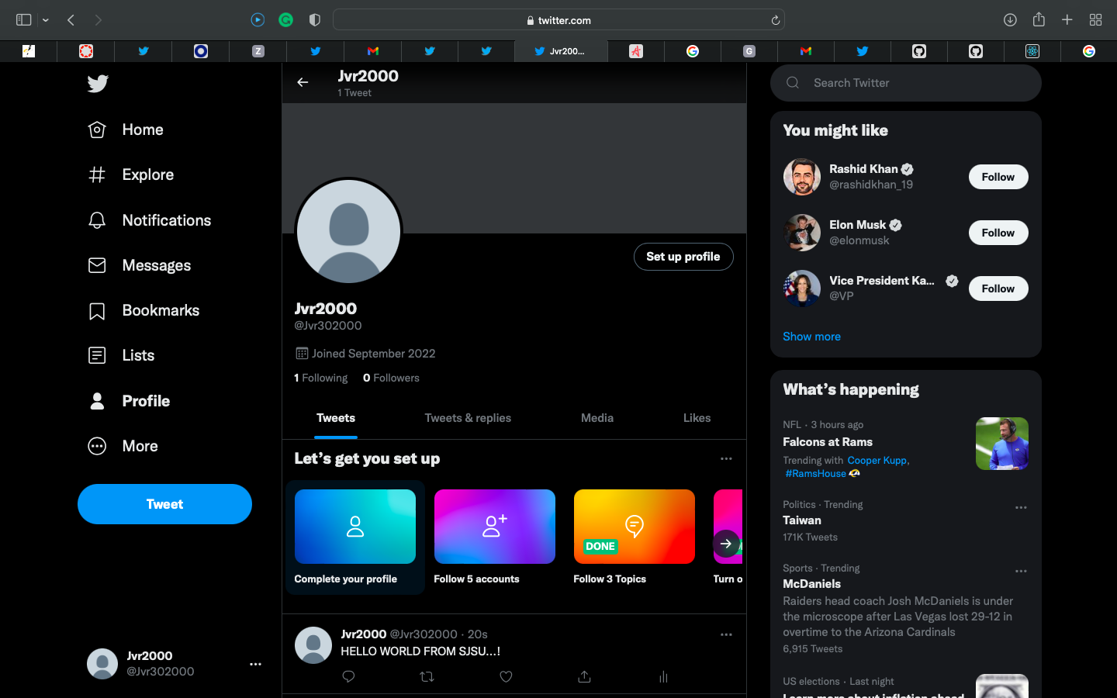

**Deleting a TWEET using Tweet ID:**

• As we discussed in the above feature of returning the TWEET ID along with the created Tweet. The same generated ID is used to delete a tweet.

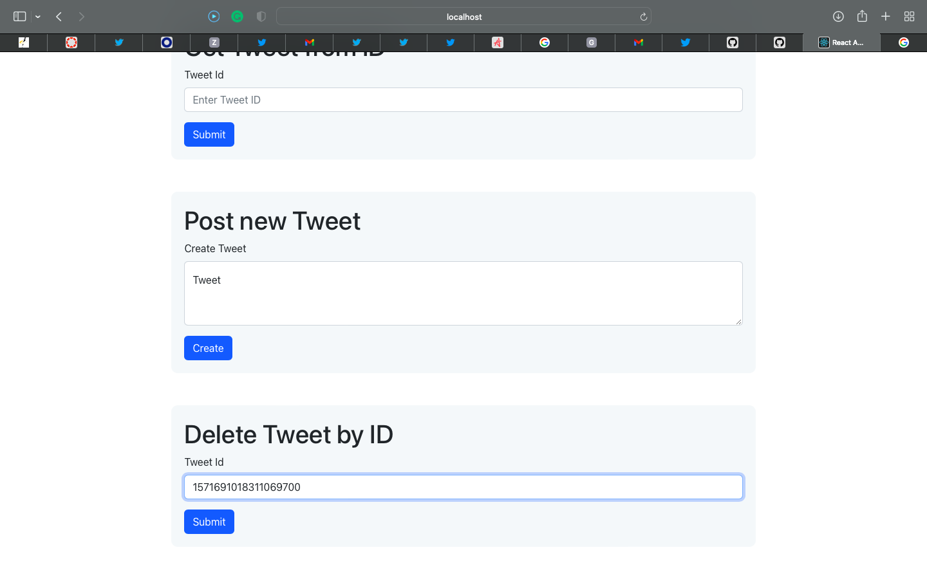

• Here’s the output of my model. The tweet got deleted with the Tweet ID.

